EXPERIMENT–1

USER INTERFACE AND DESIGN
COMPARISON OF UI DESIGN BETWEEN TWO FIGMA CREATIONS
BAD WEBSITE:
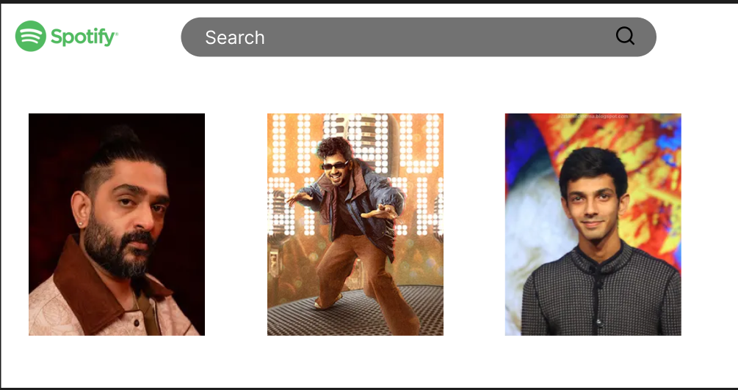
Design Style:
- The interface uses a plain white background with minimal visual hierarchy.
- Artist cards are placed without sufficient spacing, alignment, or visual grouping.
- The overall design feels static and unfinished, lacking depth and contrast.
- Typography is inconsistent with Spotify’s brand identity and feels generic.
Content:
- Displays only artist images without proper labels, descriptions, or interaction cues.
- No clear indication of actions such as “Top Songs” or “Playlists”.
- Content presentation lacks context, making it difficult for users to understand what to do next.
Navigation:
- Search bar is present but visually disconnected from the rest of the interface.
- No clear navigation structure for exploring artists, songs, or playlists.
- Missing dropdowns, categories, or guided navigation paths.
Color and Visual Appeal:
- Overuse of white space without purposeful design intent.
- Poor contrast between elements, making the UI look empty rather than clean.
- Does not reflect Spotify’s dark, immersive music-focused experience.
Purpose:
- Appears to be a basic layout prototype rather than a functional music application.
- Fails to engage users or encourage interaction.
- Not effective for music discovery or user retention.

GOOD WEBSITE:
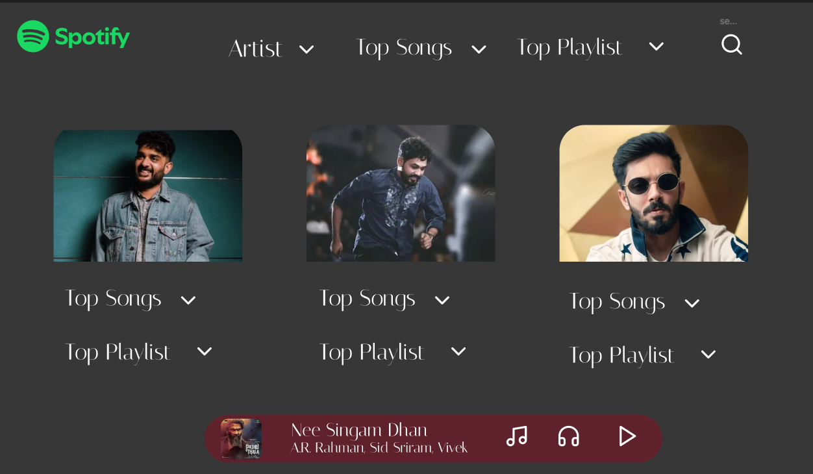

Design Style:
- Uses a dark theme, consistent with Spotify’s official design language.
- Artist cards are well-structured with rounded corners and consistent spacing.
- Proper alignment and layout hierarchy improve readability and aesthetics.
- The design feels modern, immersive, and professional.
Content:
- Clearly displays artists along with Top Songs and Top Playlist options.
- Dropdown indicators guide users toward available interactions.
- Includes a music player bar at the bottom showing the currently playing track, artist name, and playback controls.
Navigation:
- Well-defined navigation menu including:
  - Artist
  - Top Songs
  - Top Playlist
  - Search
- Dropdown menus improve discoverability and reduce screen clutter.
- Navigation is intuitive and user-friendly.
Color and Visual Appeal:
- Dark background enhances focus on artist images and content.
- Accent colors are used effectively for highlights and active elements.
- Creates a rich and engaging visual experience suitable for long usage.
Purpose:
- Designed for music exploration, playback, and engagement.
- Encourages users to browse artists, listen to songs, and explore playlists.
- Aligns well with real-world Spotify user expectations.

KEY DIFFERENCES:
- Focus:
  - Bad design focuses only on displaying images.
  - Good design focuses on interaction, exploration, and usability.
- Design Aesthetics:
  - Bad design is flat and visually weak.
  - Good design is immersive, balanced, and visually appealing.
- Content Depth:
  - Bad design provides minimal information.
  - Good design offers contextual actions like top songs, playlists, and playback.
- User Experience:
  - Bad design causes confusion and lacks engagement.
  - Good design provides clarity, ease of use, and a seamless music experience.
- Brand Consistency:
  - Bad design does not reflect Spotify’s branding.
  - Good design closely follows Spotify’s real application UI principles.

